VICTORIAN PAINTINGS

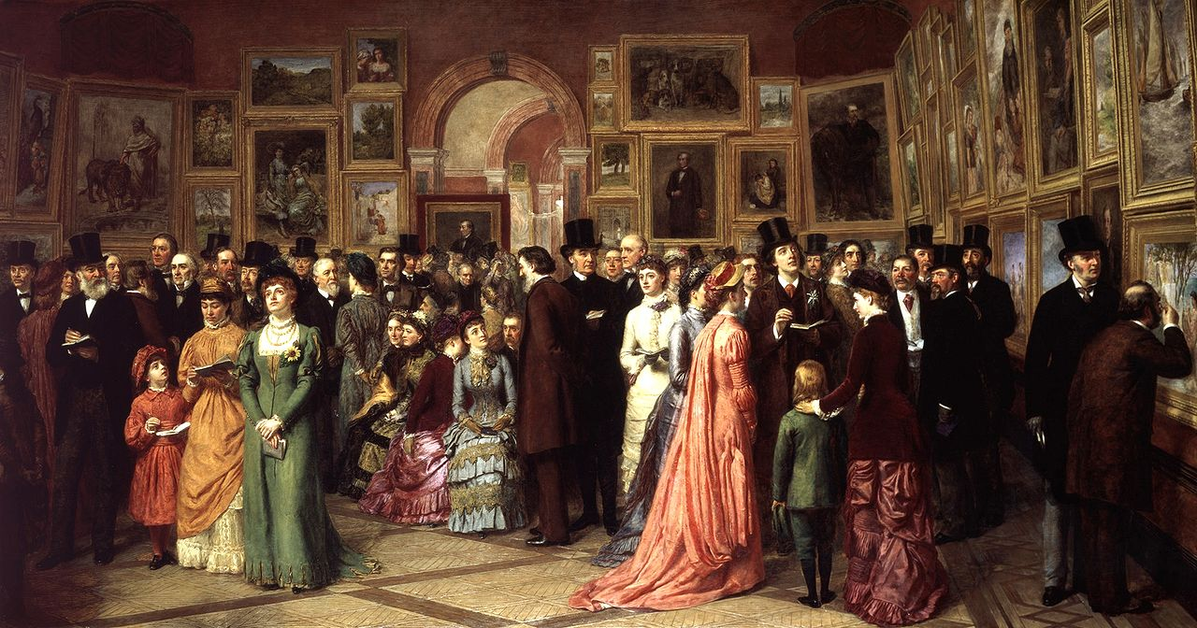

Submitted by:
Submitted to: Mam Sonia Samee

Victorian painting refers to the distinctive styles of painting in the United Kingdom during the reign of Queen Victoria (1837–1901).
Victoria's early reign was characterized by rapid industrial development and social and political change, which made the United Kingdom one of the most powerful and advanced nations in the world. Painting in the early years of her reign was dominated by the Royal Academy of Arts and by the theories of its first president, Joshua Reynolds. Reynolds and the academy were strongly influenced by the Italian Renaissance painter Raphael, and believed that it was the role of an artist to make the subject of their work appear as noble and idealized as possible. This had proved a successful approach for artists in the pre-industrial period, where the main subjects of artistic commissions were portraits of the nobility and military and historical scenes. By the time of Victoria's accession to the throne this approach was coming to be seen as stale and outdated. The rise of the wealthy middle class had changed the art market, and a generation who had grown up in an industrial age believed in the importance of accuracy and attention to detail, and that the role of art was to reflect the world, not to idealise it.
In the late 1840s and early 1850s, a group of young art students formed the Pre-Raphaelite Brotherhood as a reaction against the teaching of the Royal Academy. Their works were based on painting as accurately as possible from nature when able, and when painting imaginary scenes to ensure they showed as closely as possible the scene as it would have appeared, rather than distorting the subject of the painting to make it appear noble. They also felt that it was the role of the artist to tell moral lessons, and chose subjects which would have been understood as morality tales by the audiences of the time. They were particularly fascinated by recent scientific advances which appeared to disprove thebiblical chronology, as they related to the scientists' attention to detail and willingness to challenge their own existing beliefs. Although the Pre-Raphaelite Brotherhood was relatively short-lived, their ideas were highly influential.
The Franco-Prussian War of 1870 led to a number of influential French Impressionist artists moving to London, bringing with them new styles of painting. At the same time, a severe economic depression and the increasing spread of mechanisation made British cities an increasingly unpleasant place to live, and artists turned against the emphasis on reflecting reality. A new generation of painters and writers known as the aesthetic movement felt that the domination of art buying by the poorly-educated middle class, and the Pre-Raphaelite emphasis on reflecting the reality of an ugly world, was leading to a decline in the quality of painting. The aesthetic movement concentrated on creating works depicting beauty and noble deeds, as a distraction from the unpleasantness of reality. As the quality of life in Britain continued to deteriorate, many artists turned to painting scenes from the pre-industrial past, while many artists within the aesthetic movement, regardless of their own religious beliefs, painted religious art as it gave them a reason to paint idealised scenes and portraits and to ignore the ugliness and uncertainty of reality.
The Victorian age ended in 1901, by which time many of the most prominent Victorian artists had already died. In the early 20th century the Victorian attitudes and arts became extremely unpopular. The modernist movement, which came to dominate British art, was drawn from European traditions and had little connection with 19th-century British works. Because Victorian painters had generally been extremely hostile towards these

When the 18-year-old Alexandrina Victoria inherited the throne of the United Kingdom of Great Britain and Ireland as Queen Victoria in 1837, the country had enjoyed unbroken peace since the final victory overNapoleon in 1815.^{[4]} In 1832 the Representation of the People Act (commonly known as the Reform Act) and its equivalents in Scotland and Ireland had abolished many of the corrupt practices of the British political system, giving the country a stable and relatively representative government.^{[5]} The Industrial Revolution was underway, and in 1838 the London and Birmingham Railway opened, linking the industrial north of England to the cities and ports of the south;^{[6]} by 1850 over 6,200 miles (10,000 km) of railways were in place and Britain's transformation into an industrial superpower was complete.^{[7]} The perceived triumph of technology, progress and peaceful trade was celebrated in the 1851 Great Exhibition, organised by Victoria's husbandAlbert, which attracted over 40,000 visitors per day to view the over 100,000 exhibits of manufacturing, farming and engineering on display.^{[8]}
While Britain's economy had traditionally been dominated by the landowning aristocracy of the countryside, the Industrial Revolution and political reforms had greatly reduced their influence, and created a booming middle class of merchants, manufacturers and engineers in London and the industrial cities of the north.^{[9]}The newly rich were generally keen to show off their affluence through the display of art,^{[10]} and rich enough to pay high prices for art works, but generally had little interest in the old masters, preferring modern works by local artists.^{[9]} In 1844 Parliament ruled art unions legal, which commissioned artworks by famous artists, paying for them by means of a lottery in which the finished artwork was the prize; this not only offered an entrance to the art world for people who may not have been able to afford to buy a significant painting, but stimulated a growing market for prints.

ANIMAL PAINTING:
Since the time of George Stubbs (1724–1806), Britain had had a strong tradition of animal painting, a field which had gained respect owing to James Ward's highly proficient animal paintings of the early 19th century. Selective breeding of livestock, particularly dogs, had become highly popular, leading to a lucrative market in drawings and paintings of prize-winning animals. In the early 19th century the Scottish Highlands experienced a dramatic upsurge in popularity among the wealthy of Britain, particularly for the opportunities they offered for hunting. One painter in particular, Edwin Landseer (1802–1873), took the opportunity offered by the boom in Scottish travel, travelling to Scotland for the first time in 1824 and returning each year to hunt, shoot, fish and sketch.

Landseer became well known for his paintings of the landscapes, people and particularly wildlife of Scotland, to the extent that his paintings, along with the novels of Sir Walter Scott, became the primary means through which people in the rest of the United Kingdom came to picture Scotland. His works were in such high demand that the engraving rights (the right to make printed duplicates of a work) would generally sell for at least three or four times the sale cost of each work, and it was rare for a work of his to sell for less than £1000. In 1840 Landseer suffered a bout of mental illness and suffered alcoholism and mental illness throughout the rest of his life, although he continued to work successfully. In later years he became best known as the designer of the bronze lions at the base of Nelson's Column, unveiled in 1867.
Landseer and other animal painters such as Briton Riviere also became well known for sentimental paintings of dogs. Landseer's The Old Shepherd's Chief Mourner, showing a sheepdog sitting beside a coffin, was particularly well-regarded by John Ruskin, who described it as "a touching poem upon canvas, which, it cannot be doubted, has caused many a stout heart to 'play the woman' by moving it to tears".Many of the artists of the period were keen huntsmen, and accepted as a given that nature was inherently cruel and that learning to embrace this cruelty was a mark of manliness. In this context, dogs exhibiting emotions were a highly popular topic in a time of rapidly declining religious faith, suggesting the possibility of a nobility within nature that transcended cruelty and the will to live as a driving force.

